
Owner's Guide
Stainless Steel
Care & Maintenance
Keeping grade 316 balustrade components in good condition
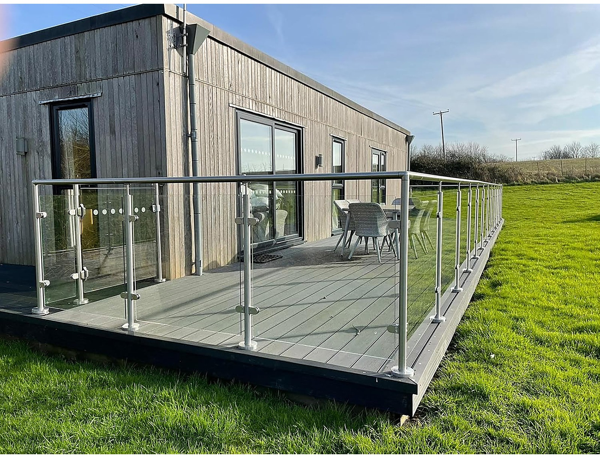

Read this guide in full before beginning installation
Why it matters
316 is corrosion resistant, not maintenance free

Grade 316 stainless steel is specified for balustrade work because it resists corrosion in exposed, coastal and marine environments where lower grades would not survive. That resistance depends on a thin, self-repairing passive layer that forms naturally on the surface in the presence of oxygen.
Dirt, dust, salt, iron particles and general grime interfere with that layer. Where contamination is left sitting on the surface, it can lead to staining, pitting and surface rust — even on 316. Properly cared for, your fittings should not corrode. Left uncleaned, they can.
The reassuring part is that stainless steel responds very well to cleaning and does not wear out from it. There is no such thing as cleaning your balustrade too often, provided you use the right products and the right method.
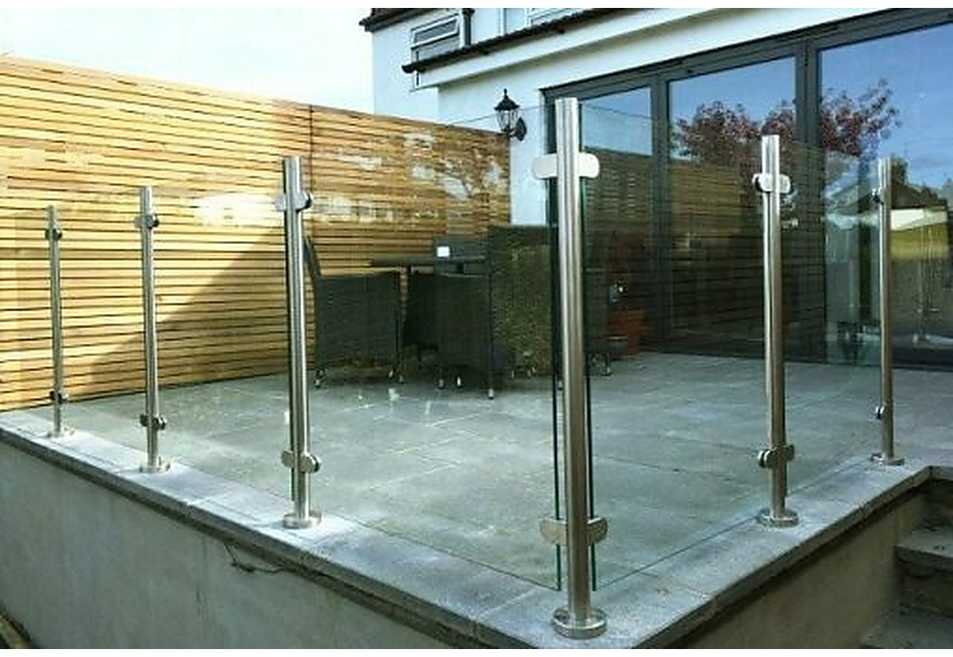
Regular cleaning keeps a coastal or exposed installation looking new
Routine care
How to clean

- Wash down with warm water and a mild detergent, using a soft cloth or sponge.
- Rinse thoroughly with clean water. Detergent residue left to dry is itself a source of staining.
- Dry with a soft towel or microfibre cloth rather than leaving to air dry, particularly in hard water areas where evaporation leaves mineral deposits.
- Always work in the direction of the brushed grain, never across it.
How often
Cleaning frequency depends almost entirely on where the balustrade is installed:
- Coastal and marine locations — every four to six weeks. Airborne salt is the most aggressive thing stainless steel faces in normal use.
- Urban and roadside locations — every two to three months, to remove traffic film and industrial fallout.
- Sheltered inland and internal locations — two or three times a year is generally sufficient.
If in doubt, look at the surface. Visible film, water spotting or a dulling of the finish means it is time.
Pay particular attention to
Contamination collects where water sits and where surfaces meet. These are the areas to check first:
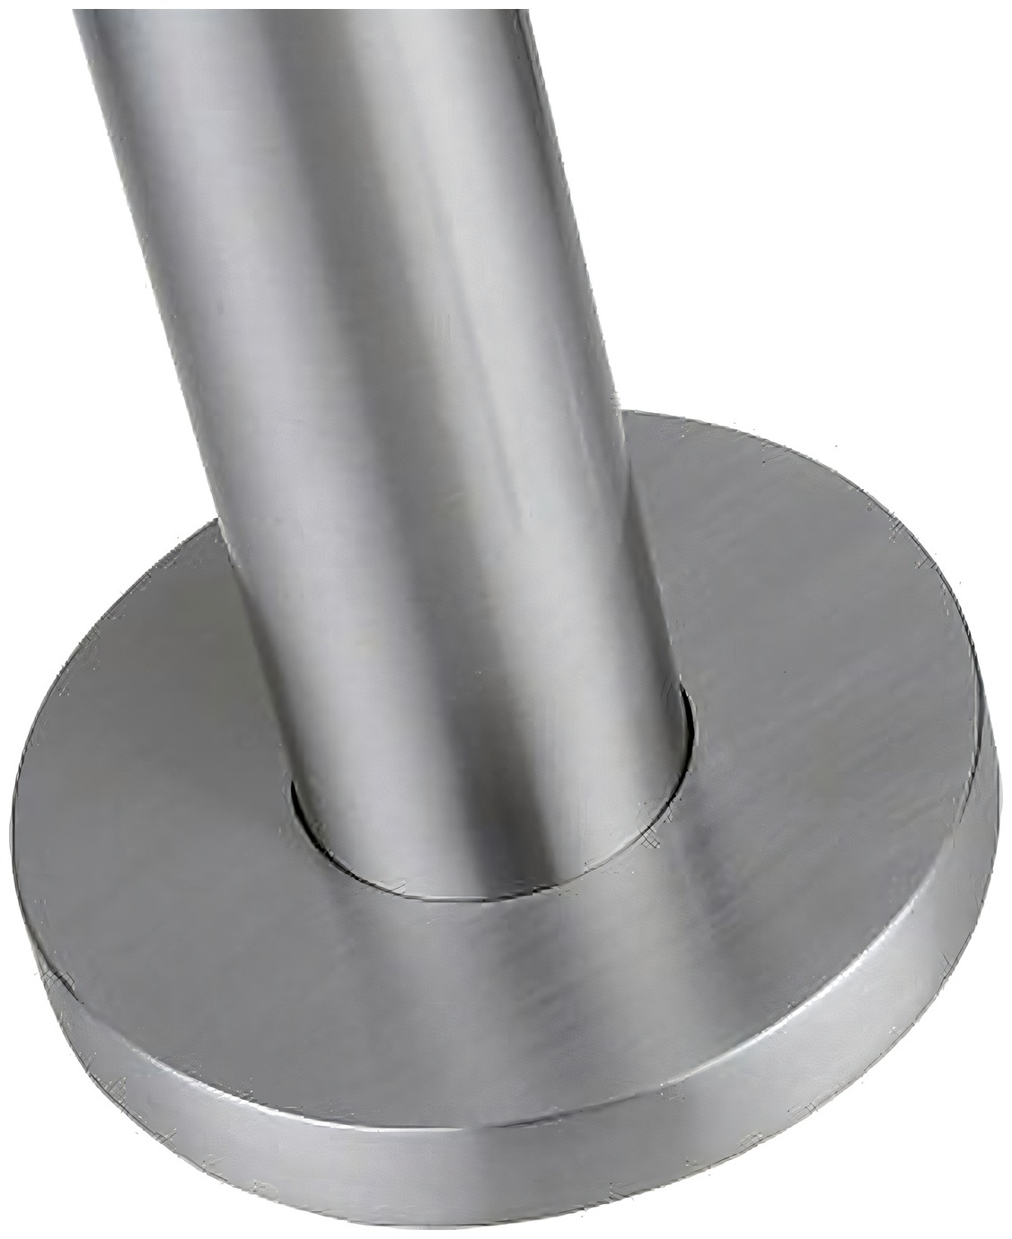  Base plates — water and debris collect at the foot | 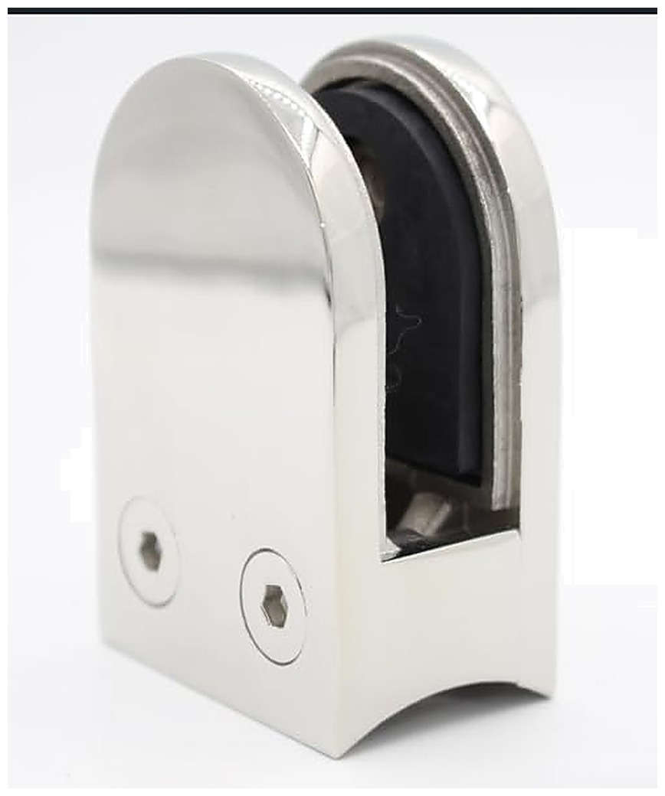  Clamp faces — check the glass line and rubber seats
- Base plates and the joint between plate and substrate.
- The underside of clamps and the line where the clamp meets the glass.
- Handrail saddles, connectors and the underside of the tube.
- Any face that sits in shade and stays damp longer after rain.
Marks and staining
When cleaning is not enough

Where routine washing does not shift a mark, a proprietary stainless steel cleaner or polish is the next step. Products of this kind lift staining, reduce the appearance of light scratching, and leave a protective film behind.
- Read the manufacturer's directions and follow them.
- Test on a small, inconspicuous area first.
- Apply along the grain, never across it.
- Rinse thoroughly and towel dry afterwards.
If surface rust appears
Light orange staining on stainless steel is usually contamination sitting on the surface rather than corrosion of the steel underneath, and in most cases a proprietary stainless steel cleaner will remove it. Where it persists, a specialist passivation or pickling product will restore the passive layer.
Address it promptly. Surface contamination left in place will eventually pit the steel beneath it, and pitting cannot be polished out.

What to avoid
The following will damage stainless steel and must never be used on your balustrade.

- Steel wool, wire brushes and abrasive pads. These embed carbon steel particles in the surface, which then rust and stain the stainless around them.
- Chloride-based and bleach-based cleaners. Chlorides attack the passive layer directly and are a common cause of pitting.
- Hydrochloric acid, including many patio, brick and masonry cleaners. Keep these well away from stainless fittings and rinse immediately on any accidental contact.
- Any cloth, pad or tool previously used on ordinary carbon steel.
A note on the glass
Clean toughened glass with a non-abrasive glass cleaner and a soft cloth. Do not use scrapers, blades or abrasive pads on the glass surface, and take care not to allow metal cleaning products to dry on the glass — some will etch it.
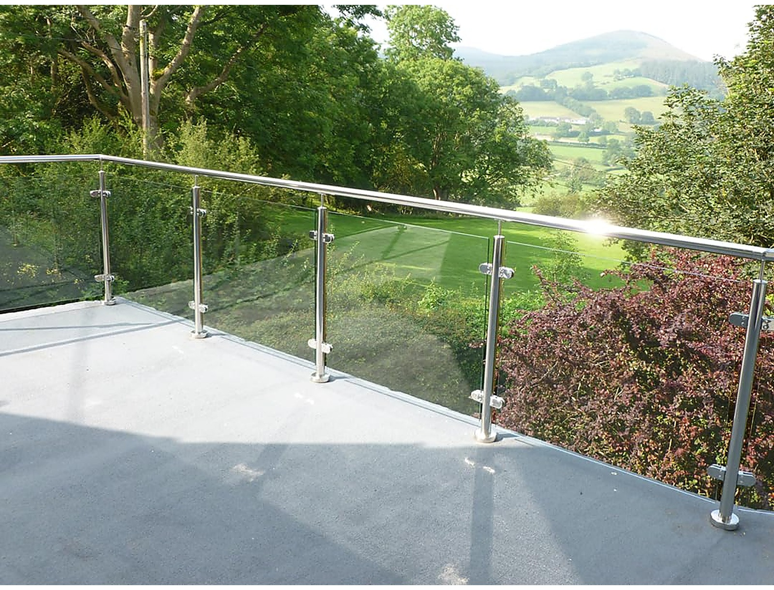

Chelmer Glass & Co
Premium glazing, expertly supplied

